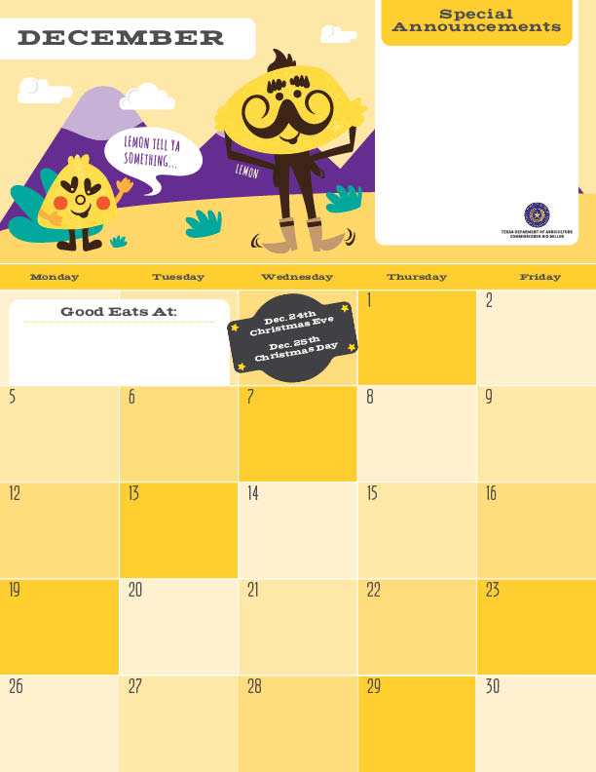Breakfast

The end of the year is here! Now is a time to reflect on the food choices we have made this year. The new fruit you tried, that cool vegetable that you didn’t know you liked, or the new salad dressing that tasted amazing!! Next year try out more new and different food choices in your everyday life. You never know what your next favorite food will be!

Egg and Bacon Taco>

Assorted Fruits

Milk

Lemon Poppy Pancake^>

Turkey Bacon

Orange

Milk

Agave

\*Gluten Free ^Dairy >Egg `Fish "Apple

Menu subject to change based on availability and costs

mario.alvarado@austin.utexas.edu kimberlywilson@austin.utexas.edu

Egg and Cheese Taco^>

Applesauce"

Milk

Cinnamon Toast Bagel

Grapefruit

Milk

No School :)

No School :)

Scrambled Eggs>

Wheat Biscuits

Banana

Milk

Turkey Sausage Patty

Wheat Biscuits

Banana

Milk

Egg and Sausage Taco>

Assorted Fruits

Milk

Wheat Pancakes^>

Turkey Bacon

Orange

Milk

Agave Nectar

No School :)

No School :)

Egg and Cheese Taco^>

Applesauce"

Milk

No School :)

No School :)

Baked Banana Crisp\*

Grapefruit

Milk

No School :)

No School :)

Egg and Potato Taco>

Assorted Fruits

Milk

Peppermint Pancake^>

Turkey Bacon

Orange

Milk

Agave

No School :)

No School :)

