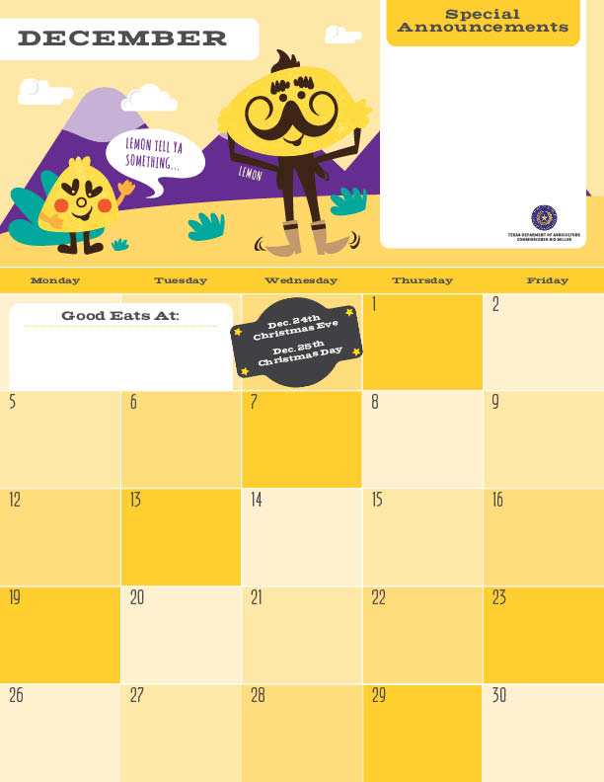Lunch

The end of the year is here! Now is a time to reflect on the food choices we have made this year. The new fruit you tried, that cool vegetable that you didn’t know you liked, or the new salad dressing that tasted amazing!! Next year try out more new and different food choices in your everyday life. You never know what your next favorite food will be!

Cheese Pizza^>

Chef Salad

Super Berry Applesauce

Milk

Hawaiian Fried Rice\*

Green Beans

Banana

Milk

\*Gluten Free ^Dairy >Egg `Fish "Apple

Menu subject to change based on availability and costs

mario.alvarado@austin.utexas.edu kimberlywilson@austin.utexas.edu

Silly Bean Chili

Wheat Roll

Carrot Coins

Apple

Milk

Korean BBQ Pork Taco

Crunchy Slaw

BBQ Beans

Pear

Milk

No School :)

No School :)

Rosemary Chicken

Wheat Roll

Broccoli Florets

Banana

Milk

Lemon Pepper Chicken

Rice

Peas

Orange

Milk

Mexican Pizza^

Caesar Salad`

Applesauce

Milk

Spaghetti w/ Meat Sauce

Green Beans

Banana

Milk

Philly Cheese Steak Mac^

Roasted Sweet Potatoes

Pear

Milk

No School :)

No School :)

Fiesta Taco Bake\*

Chili Cucumber

Orange

Milk

No School :)

No School :)

Catfish Taco`

Cilantro Lime Slaw

Black Beans

Apple

Milk

No School :)

No School :)

Cheese Pizza^>

Carrot Raisin Salad

Assorted Fruits

Milk

No School :)

No School :)

