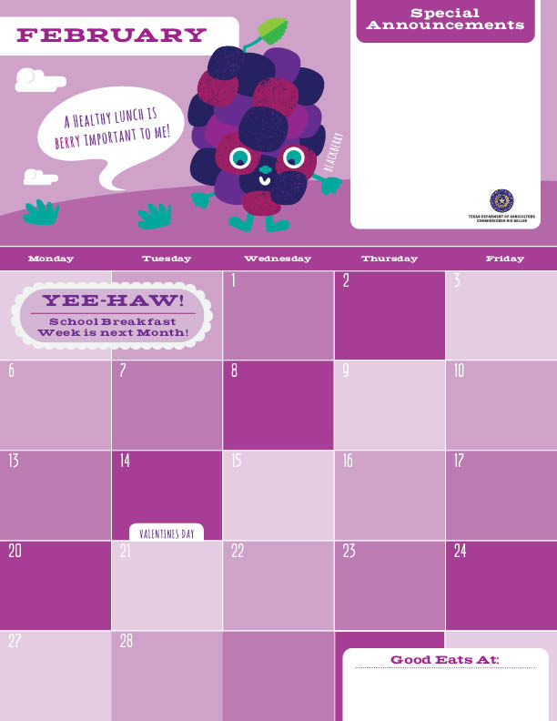Breakfast

The weather has been crazy but you can always count on the UTES Chefs to be here cooking great tasting, made from scratch food items every day. Don’t forget to crunch down on those fresh fruits we give out too. Getting everything you need for a well-balanced meal twice a day is our pleasure. Look ahead to see when your favorite items are on the menu and tell your friends about why you love that menu item.

See you in the café soon!

Eggs and Bacon Taco>

Assorted Fruits

Milk

Wheat Pancakes^>

Turkey Bacon

Orange

Milk

Agave Nectar

Turkey Sausages

Wheat Biscuits

Banana

Milk

Cinnamon Toast Bagel

Grapefruit

Milk

Egg and Cheese Taco^>

Applesauce

Milk

Egg and Cheese Taco^>

Applesauce

Milk

Strawberry Fruity Toast^

Grapefruit

Milk

Egg and Cheese Taco^>

Applesauce

Milk

Egg and Potato Taco>

Assorted Fruits

Milk

Scrambled Eggs

Wheat Biscuits

Banana

Milk

Strawberry Pancakes^>

Turkey Bacon

Orange

Milk

Agave Nectar

Baked Apple Crisp”^

Grapefruit

Milk

No School ☺

Wheat Pancakes^>

Turkey Bacon

Orange

Milk

Agave Nectar

Chicken Patty

Wheat Biscuit

Applesauce

Milk

Cowboy Eggs Taco^>

Assorted Fruits

Milk

Blueberry Pancakes^>

Turkey Bacon

Orange

Milk

Agave Nectar

Turkey Sausages

Wheat Biscuits

Banana

Milk

Cinnamon Sugar Oatmeal

Grapefruit

Milk

Egg and Cheese Taco^>

Applesauce

Milk

\*Gluten Free ^Dairy >Egg `Fish "Apple

Menu subject to change based on availability and costs

mario.alvarado@austin.utexas.edu kimberlywilson@austin.utexas.edu

