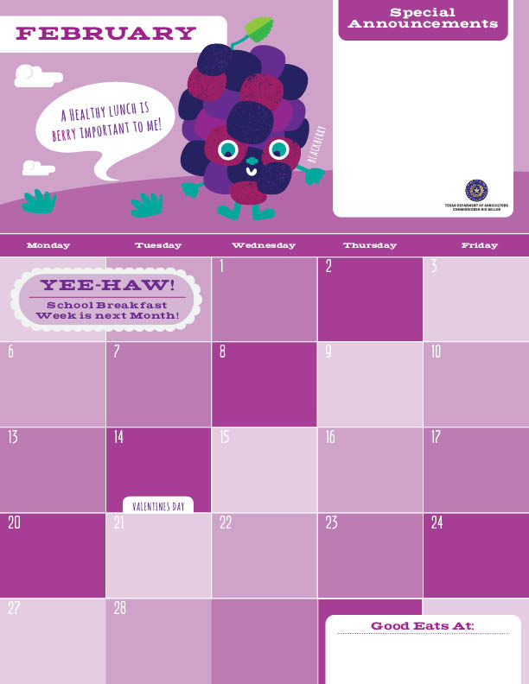Lunch

The weather has been crazy but you can always count on the UTES Chefs to be here cooking great tasting, made from scratch food items every day. Don’t forget to crunch down on those fresh fruits we give out too. Getting everything you need for a well-balanced meal twice a day is our pleasure. Look ahead to see when your favorite items are on the menu and tell your friends about why you love that menu item.

See you in the café soon!

Cheese Pizza^>

Chef Salad’

Applesauce”

Milk

Hawaiian Fried Rice\*

Cauliflower

Banana

Milk

Catfish Strips’

Wheat Roll

Hatch Chili Corn

Grapes

Milk

BBQ Fish Taco’

Lettuce and Pico De Gallo

Refried Beans

Apple

Milk

Grilled Cheese Sandwich

Tomato Basil Soup

Roasted Cauliflower

Pear

Milk

Fiesta Taco Bake\*^

Chili Cucumber Slices

Orange

Milk

Fish Taco’

Cilantro Lime Slaw

Black Beans

Apple

Milk

Veggie Fried Rice\*>

Broccoli Florets

Pear

Milk

Mexican Pizza^>

Caesar Salad’

Applesauce

Milk

BBQ Pork

Brown Rice

Steamed Corn

Grapes

Milk

Spaghetti

Meaty Marinara Sauce

Green Beans

Banana

Milk

Lemon Pepper Pork Taco

Lettuce and Tomato

Fiesta Beans

Apple

Milk

No School ☺

Philly Cheese Mac^

Sweet Potatoes

Banana

Milk

Catfish Strips’

Wheat Roll

Broccoli Florets

Grapes

Milk

Cheese Pizza^>

Chef Salad

Applesauce

Milk

Cheeseburger Mac^

Carrot Coins

Banana

Milk

Mojo Pork

Brown Rice

Corn, Carrots, and Peas

Grapes

Milk

SW Turkey Taco

Pico de Longhorn

Fiesta Beans

Apple

Milk

Lasagna Bake<^

Broccoli Florets

Pear

Milk

\*Gluten Free ^Dairy >Egg `Fish "Apple

Menu subject to change based on availability and costs

mario.alvarado@austin.utexas.edu kimberlywilson@austin.utexas.edu

