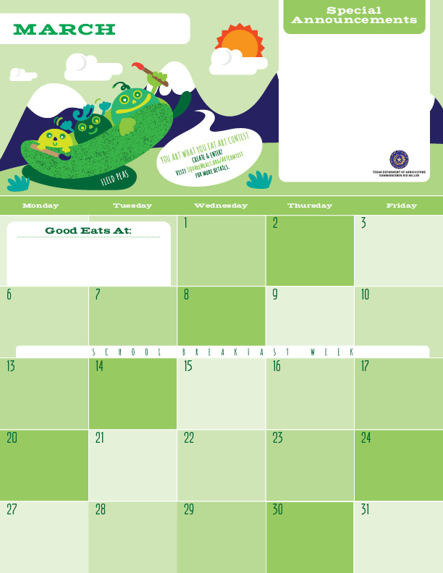

Breakfast

Spring is here!! Our wellness class students are hard at work in the campus gardens harvesting fresh greens and herbs to use in the Café. The Chef’s love to use these home grown vegetables in the salads on Friday. There are so many other things that can be done with all the greens from your home garden. Use them in smoothies, sauté them with herbs and garlic for a delicious side dish, or even thrown them in a soup for added flavor, texture, and fiber.

*Gluten Free ^Dairy >Egg `Fish "Apple

**Menu subject to change based on availability and costs**

mario.alvarado@austin.utexas.edu kimberlywilson@austin.utexas.edu

Egg and Potato Taco>

Assorted Fruits

Milk

Wheat Pancakes^>

Turkey Bacon

Orange

Milk

Agave Nectar

Scrambled Eggs>

Wheat Biscuits

Banana

Milk

Spring Break ☺

Banana Pancakes^>

Turkey Bacon

Orange

Milk

Agave Nectar

Egg and Cheese Taco^>

Applesauce”

Milk

Cinnamon Toast Bagel

Grapefruit

Milk

Chicken Patty

Wheat Biscuit

Banana

Milk

Spring Break ☺

Spring Break ☺

Spring Break ☺

Spring Break ☺

Spring Break ☺

Egg and Sausage Taco>

Assorted Fruits

Milk

Wheat Pancakes^>

Turkey Bacon

Orange

Milk

Agave Nectar

Turkey Sausages

Wheat Biscuits

Banana

Milk

Egg and Cheese Taco>^

Applesauce”

Milk

Spring Break ☺

Apple Cinnamon Pancakes^>

Turkey Bacon

Orange

Milk

Agave Nectar

Egg and Bacon Taco>

Assorted Fruits

Milk

Scrambled Eggs>

Wheat Biscuits

Banana

Milk

Baked Banana Crisp>

Grapefruit

Milk

Egg and Cheese Taco^>

Applesauce”

Milk

