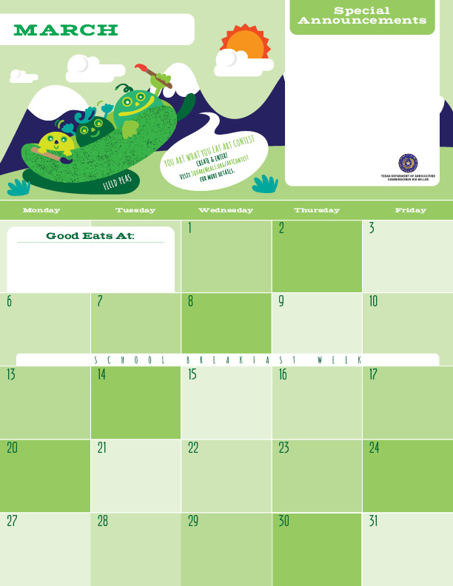

Lunch

Spring is here!! Our wellness class students are hard at work in the campus gardens harvesting fresh greens and herbs to use in the Café. The Chef’s love to use these home grown vegetables in the salads on Friday. There are so many other things that can be done with all the greens from your home garden. Use them in smoothies, sauté them with herbs and garlic for a delicious side dish, or even thrown them in a soup for added flavor, texture, and fiber.

Hamburger w/ Wheat Bun

Lettuce and Tomato

Steamed Corn

Peach Cup

Milk

*Gluten Free ^Dairy >Egg `Fish "Apple

**Menu subject to change based on availability and costs**

mario.alvarado@austin.utexas.edu kimberlywilson@austin.utexas.edu

Garlic and Herb Pizza^>

Chef Salad

Apricot Cup

Milk

Beef and Broccoli

Brown Rice

Peas and Carrots

Banana

Milk

Hamburger w/ Wheat Bun

Lettuce and Tomato

Green Beans

Peach Cup

Milk

Chicken Fajita Taco

Lettuce and Pico de Gallo

Fiesta Beans

Apple

Milk

Spring Break ☺

Meatloaf*

Mashed Potatoes

Wheat Roll

Applesauce

Milk

Veggie Fried Rice*>

Sesame Cucumbers

Pear

Milk

Spring Break ☺

Spring Break ☺

Spring Break ☺

Spring Break ☺

Spring Break ☺

Chicken Enchilada Pasta^

Green Beans

Banana

Milk

Hamburger w/ Wheat Bun

Lettuce and Tomato

BBQ Baked Beans

Peach Cup

Milk

Cheese Pizza^>

Caesar Salad’

Applesauce

Milk

Catfish Taco

Cilantro Line Coleslaw

Steamed Broccoli

Apple

Milk

Spring Break ☺

Pulled Pork Taco

Lettuce and Pico De Gallo

Black Beans

Apple

Milk

Hamburger w/ Wheat Bun

Lettuce and Tomato

Hatch Chili Corn

Fruit Cup

Milk

Hawaiian Fried Rice*

Cauliflower

Orange

Milk

BBQ Pizza^>

Chef Salad

Applesauce

Milk

Veggie Mac N Cheese^

Broccoli Florets

Pear

Milk

