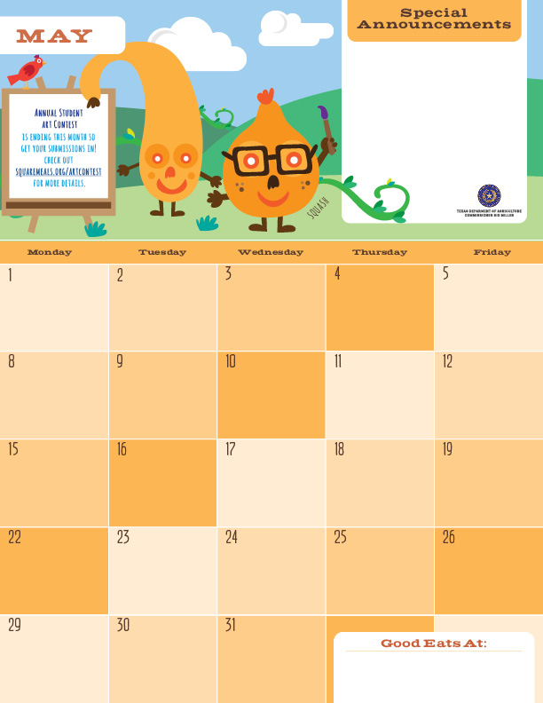

Lunch

Woo Hoo!!! You all have made it through another school year!! Remember all the new and delicious foods you tried at school this year in our Café. Coconut Curry Chicken, Mexican Pizza, Philly Cheese Macaroni, and everyone’s favorite… Caesar Salad ☺ When you are away look for items you may have had at school. We serve you dishes straight from restaurant menus every day. Have a great summer and eat lots of fruits!

Veggie Mac-N-Cheese^

Broccoli Florets

Pears

Milk

Chicken Fajita Taco

Lettuce and Pico De Gallo

Tortilla

Black Beans

Chili Lime Mangoes

Milk

BBQ Pizza^>

Caesar Salad’

Applesauce”

Milk

Hamburger with Bun

Lettuce and Tomato

Cauliflower

Banana

Milk

Catfish Strips’

Wheat Roll

Mixed Veggies

Orange

Milk

Hamburger with Bun

Lettuce and Tomato

Green Beans

Banana

Milk

Eat lots of fruits…

Garlic Herb Pizza^>

Caesar Salad’

Applesauce

Milk

Cheese Pizza^>

Carrot Raisin Salad

Applesauce”

Milk

Enjoy your summer…

Hamburger with Bun

Lettuce and Tomato

BBQ Beans

Banana

Milk

Have fun ☺

BBQ Catfish Strips’

Wheat Roll

Mixed Veggies

Orange

Milk

Turkey Ham Rice

Mixed Veggies

Orange

Milk

Catfish Taco’

Cilantro Lime Slaw

Tortilla

Fiesta Beans

Apple

Milk

Silly Bean Chili

Wheat Roll

Carrot Coins

Pears

Milk

Sweet-N- Sour Turkey Ham

Peppers and Onions

Tortilla

Green Beans

Milk

Veggie Fried Rice>

Sesame Cucumbers

Pear

Milk

Lasagna Bake^

Broccoli Florets

Pear

Milk

Chicken Enchilada Taco

Lettuce and Pico De Gallo

Tortilla

Refried Beans

Apple

Milk

Cajun Catfish Strips’

Wheat Roll

Mixed Veggies

Assorted Fruits

Milk

Stay hydrated…

Don’t forget your favorite vegetables…

*Gluten Free ^Dairy >Egg `Fish "Apple

**Menu subject to change based on availability and costs**

mario.alvarado@austin.utexas.edu kimberlywilson@austin.utexas.edu

