University of Texas Elementary School Volunteer Applicants

Background Check Instructions on TxDPS Website

Start here and click on this link:
https://records.txdps.state.tx.us/DpsWebsite/index.aspx

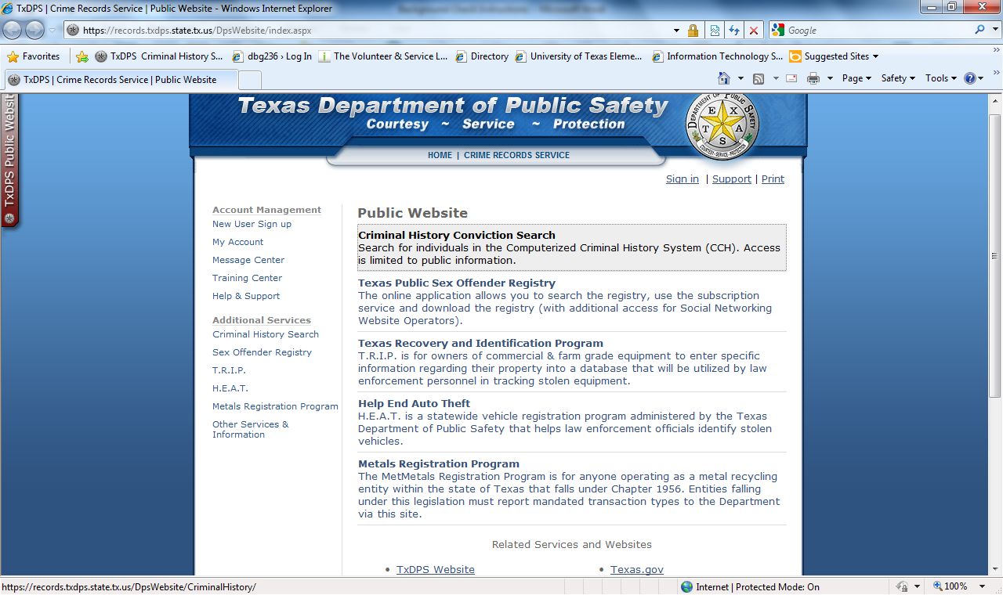

Click on “Criminal History Conviction Search” under Pubic Website.

https://records.txdps.state.tx.us/DpsWebsite/CriminalHistory/

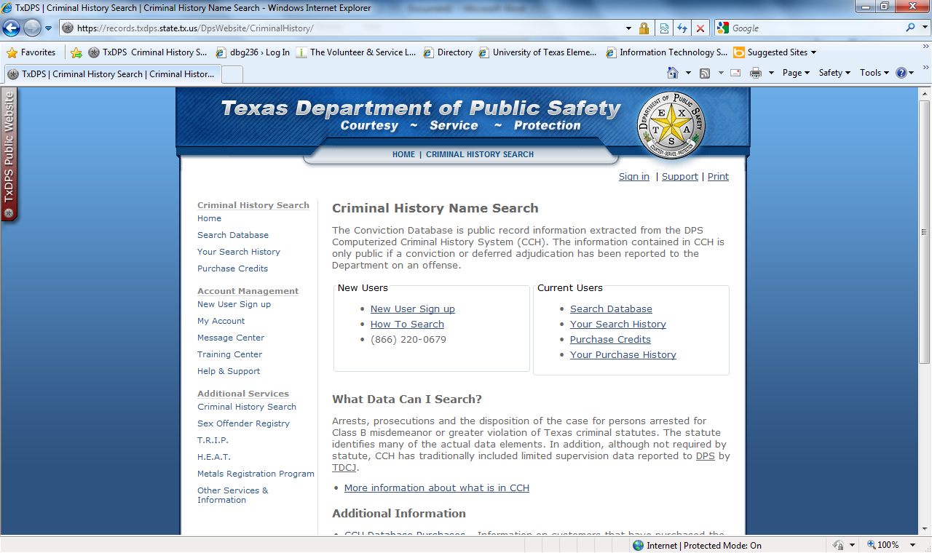

Click on “New User Sign Up.”
https://records.txdps.state.tx.us/DpsWebsite/Signup/PublicSite/index.aspx?DefaultApp=CCH
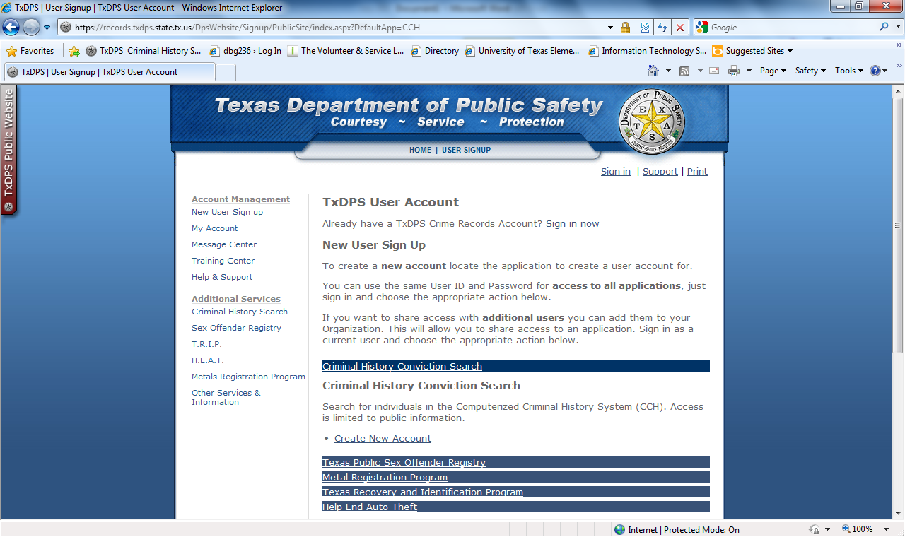
Click on “Create New Account.”
https://records.txdps.state.tx.us/DpsWebsite/Signup/PublicSite/CriminalHistory/Index.aspx?CreateNewUser=False
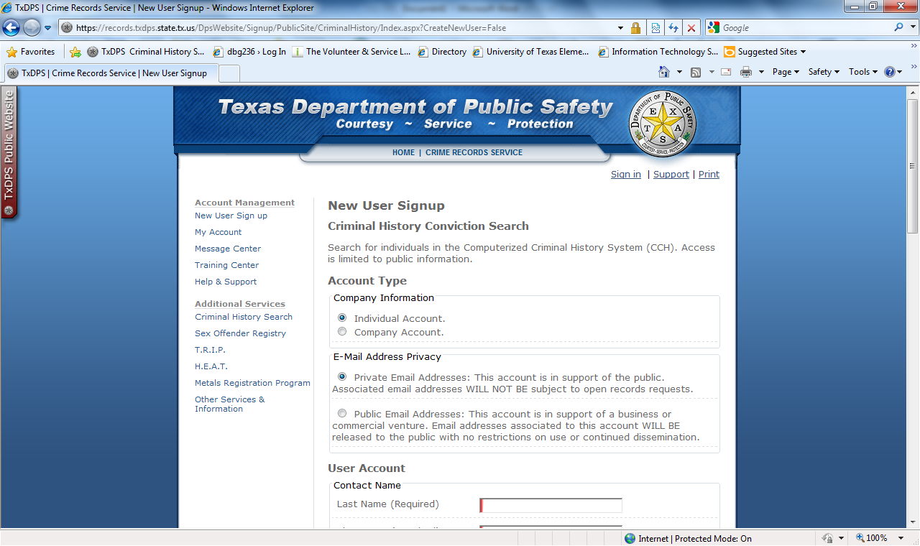
You want an individual email account with a private email address. Fill in the required information. After you sign up you will get a confirmation email. Make sure you record your password and your security question answer!
***You may get an alert that asks you to verify your email address. Follow the instructions.
https://records.txdps.state.tx.us/DpsWebsite/Profile/Index.aspx
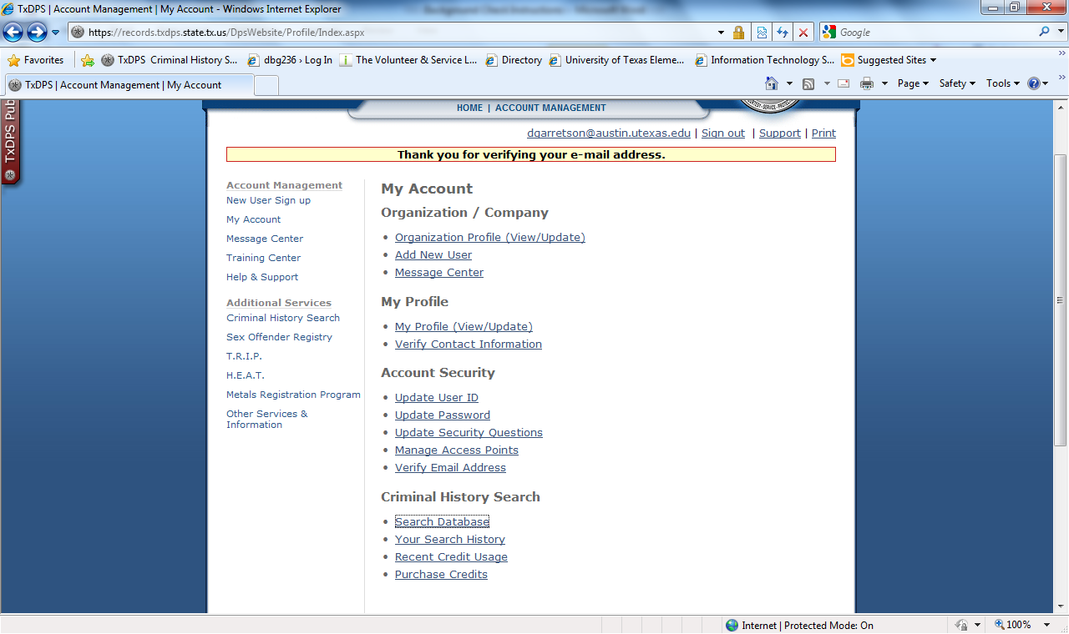
Click on “Search Database.”
https://records.txdps.state.tx.us/DpsWebsite/CriminalHistory/Application/Caveats.aspx?returnUrl=%2fDpsWebsite%2fCriminalHistory%2fApplication%2fSearch%2fIndex.aspx%3fSearchMethod%3dNam%26bypassPendingCheck%3dFalse
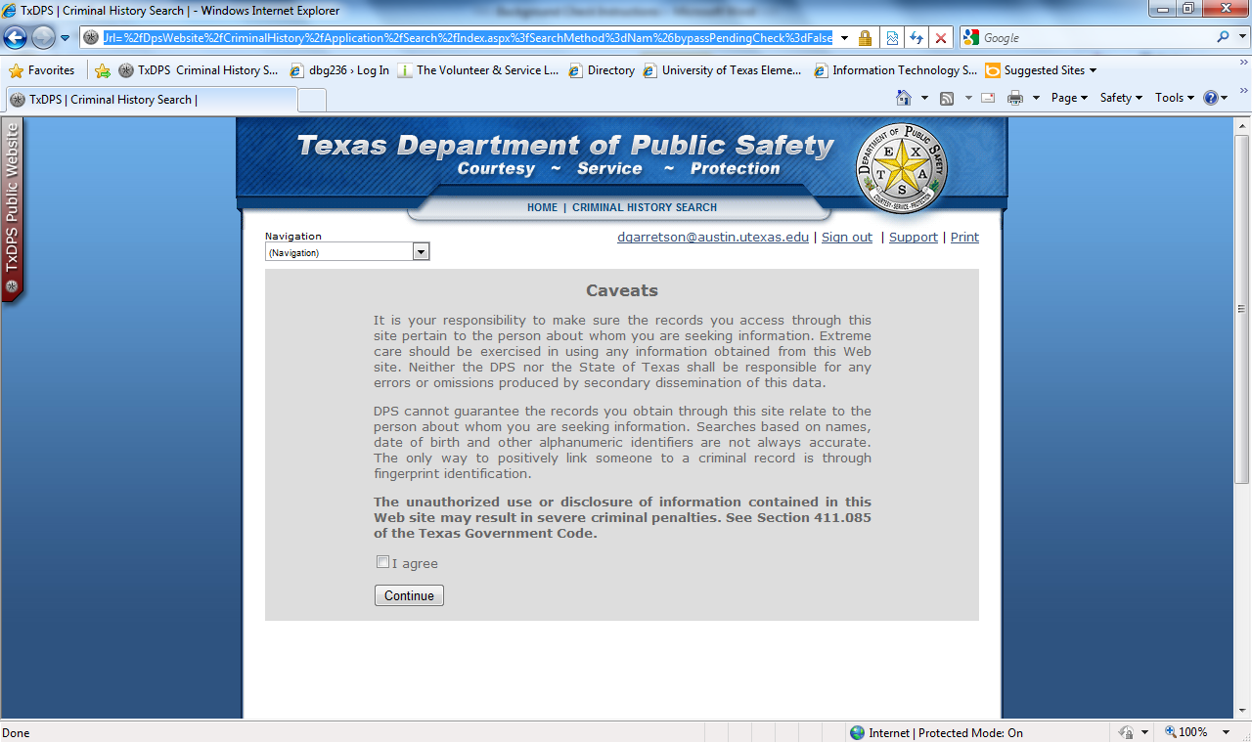

https://records.txdps.state.tx.us/DpsWebsite/CriminalHistory/Application/Search/Index.aspx?SearchMethod=Nam&bypassPendingCheck=False
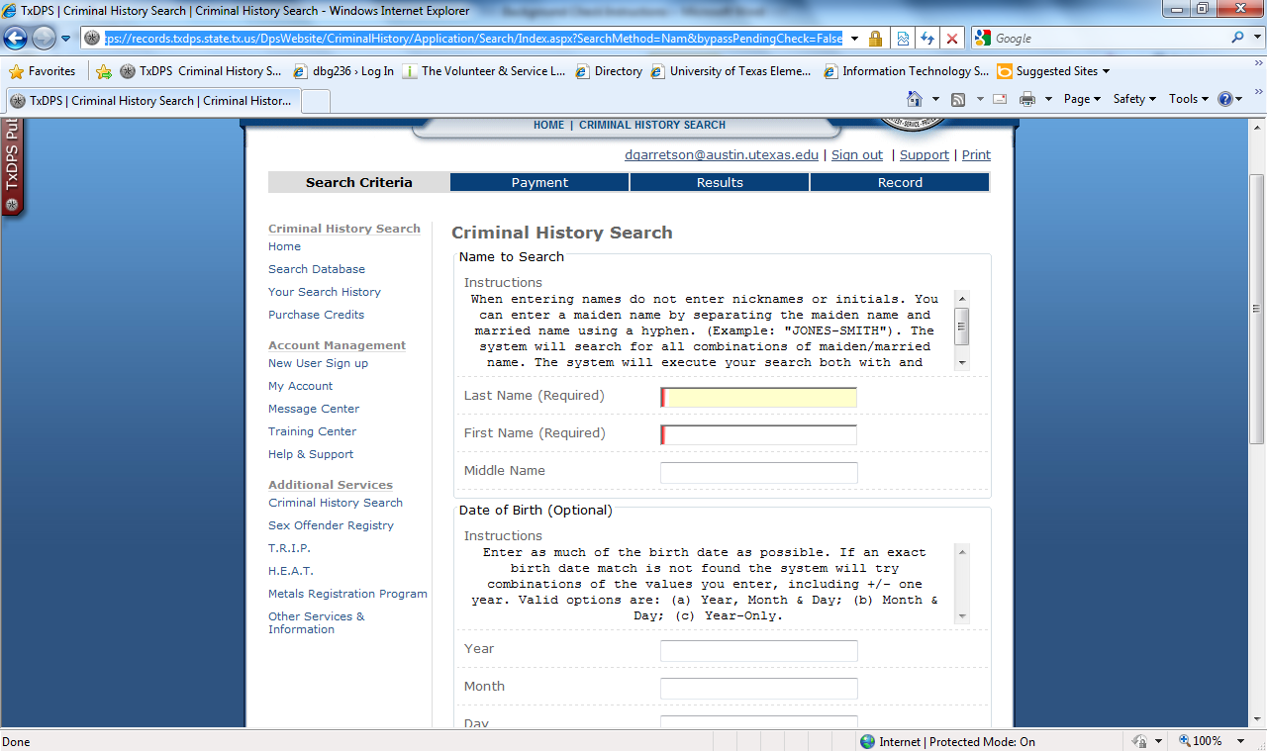
Please enter your full name and your full date of birth.
https://records.txdps.state.tx.us/DpsWebsite/CriminalHistory/Application/Search/Index.aspx?SearchMethod=Nam&bypassPendingCheck=False
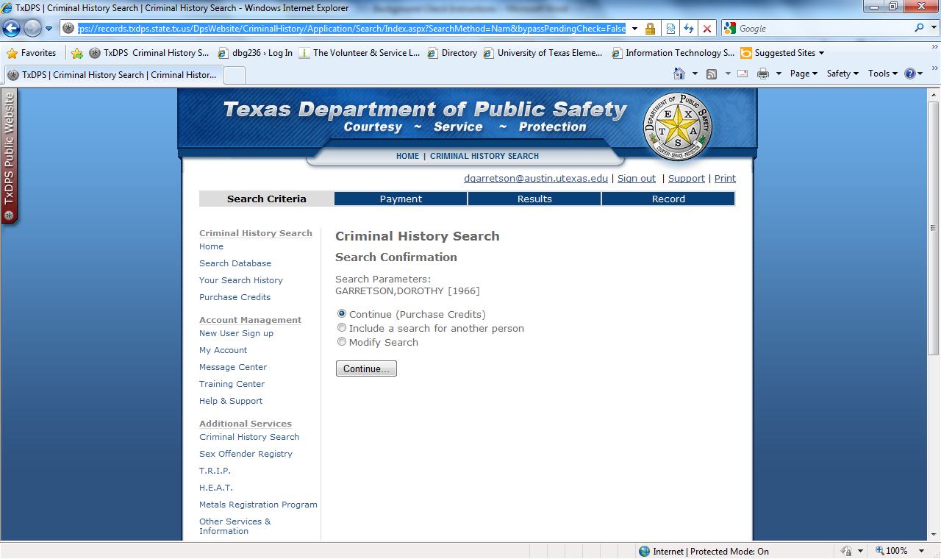
***PLEASE NOTE: This is a random birth year!
https://records.txdps.state.tx.us/DpsWebsite/CriminalHistory/Application/Conversion/Purchase.aspx?requiredCredits=1&IND_IDN=0
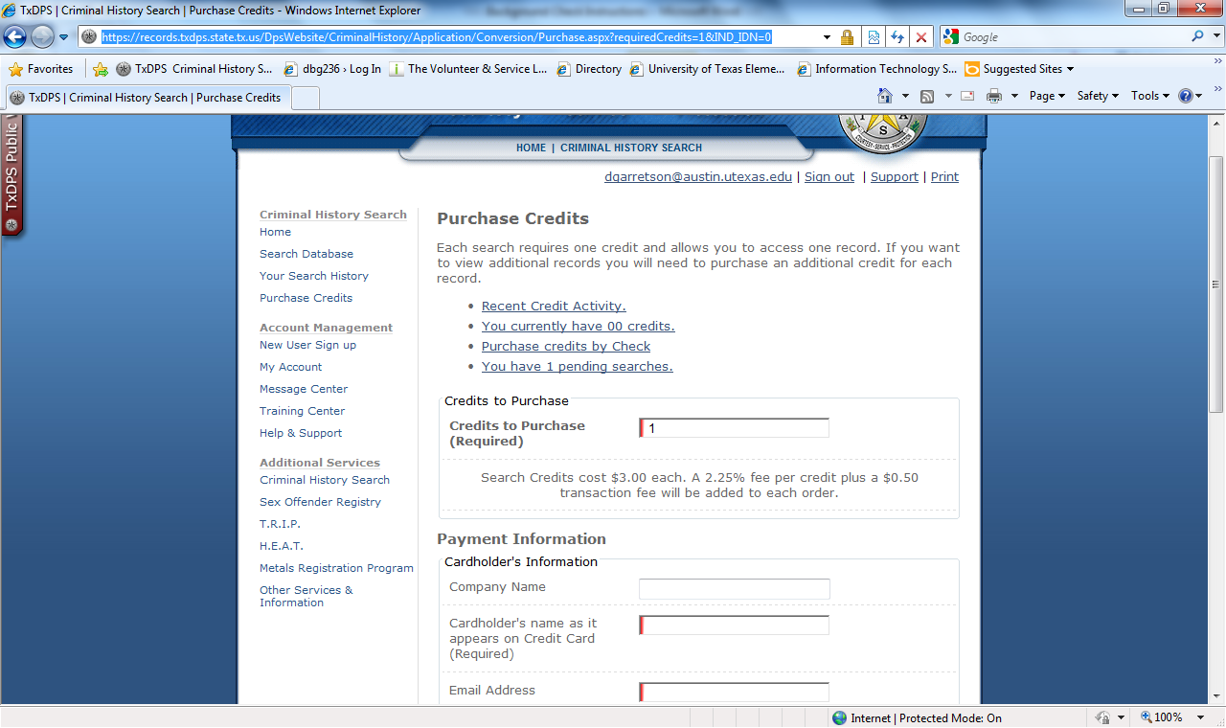
You will only want to purchase one credit in order to search for yourself. The exact cost is $3.57.
NOTE: A successful Background Check search will come back saying, “No Matches.” (The Background Check search is looking for criminal records, so “No Matches” indicate that you have no criminal record.)
[…]
After you have successfully completed your Background Check, please print the results and send them to:
Kayli Bolds, UT Elementary School University Leadership Network Intern
University of Texas Elementary School
2200 East 6th Street
Austin, TX 78702
School Phone = (512) 495-3300
Fax = (512) 232-8571
kbolds96@utexas.edu

Please include a copy of your driver license.

