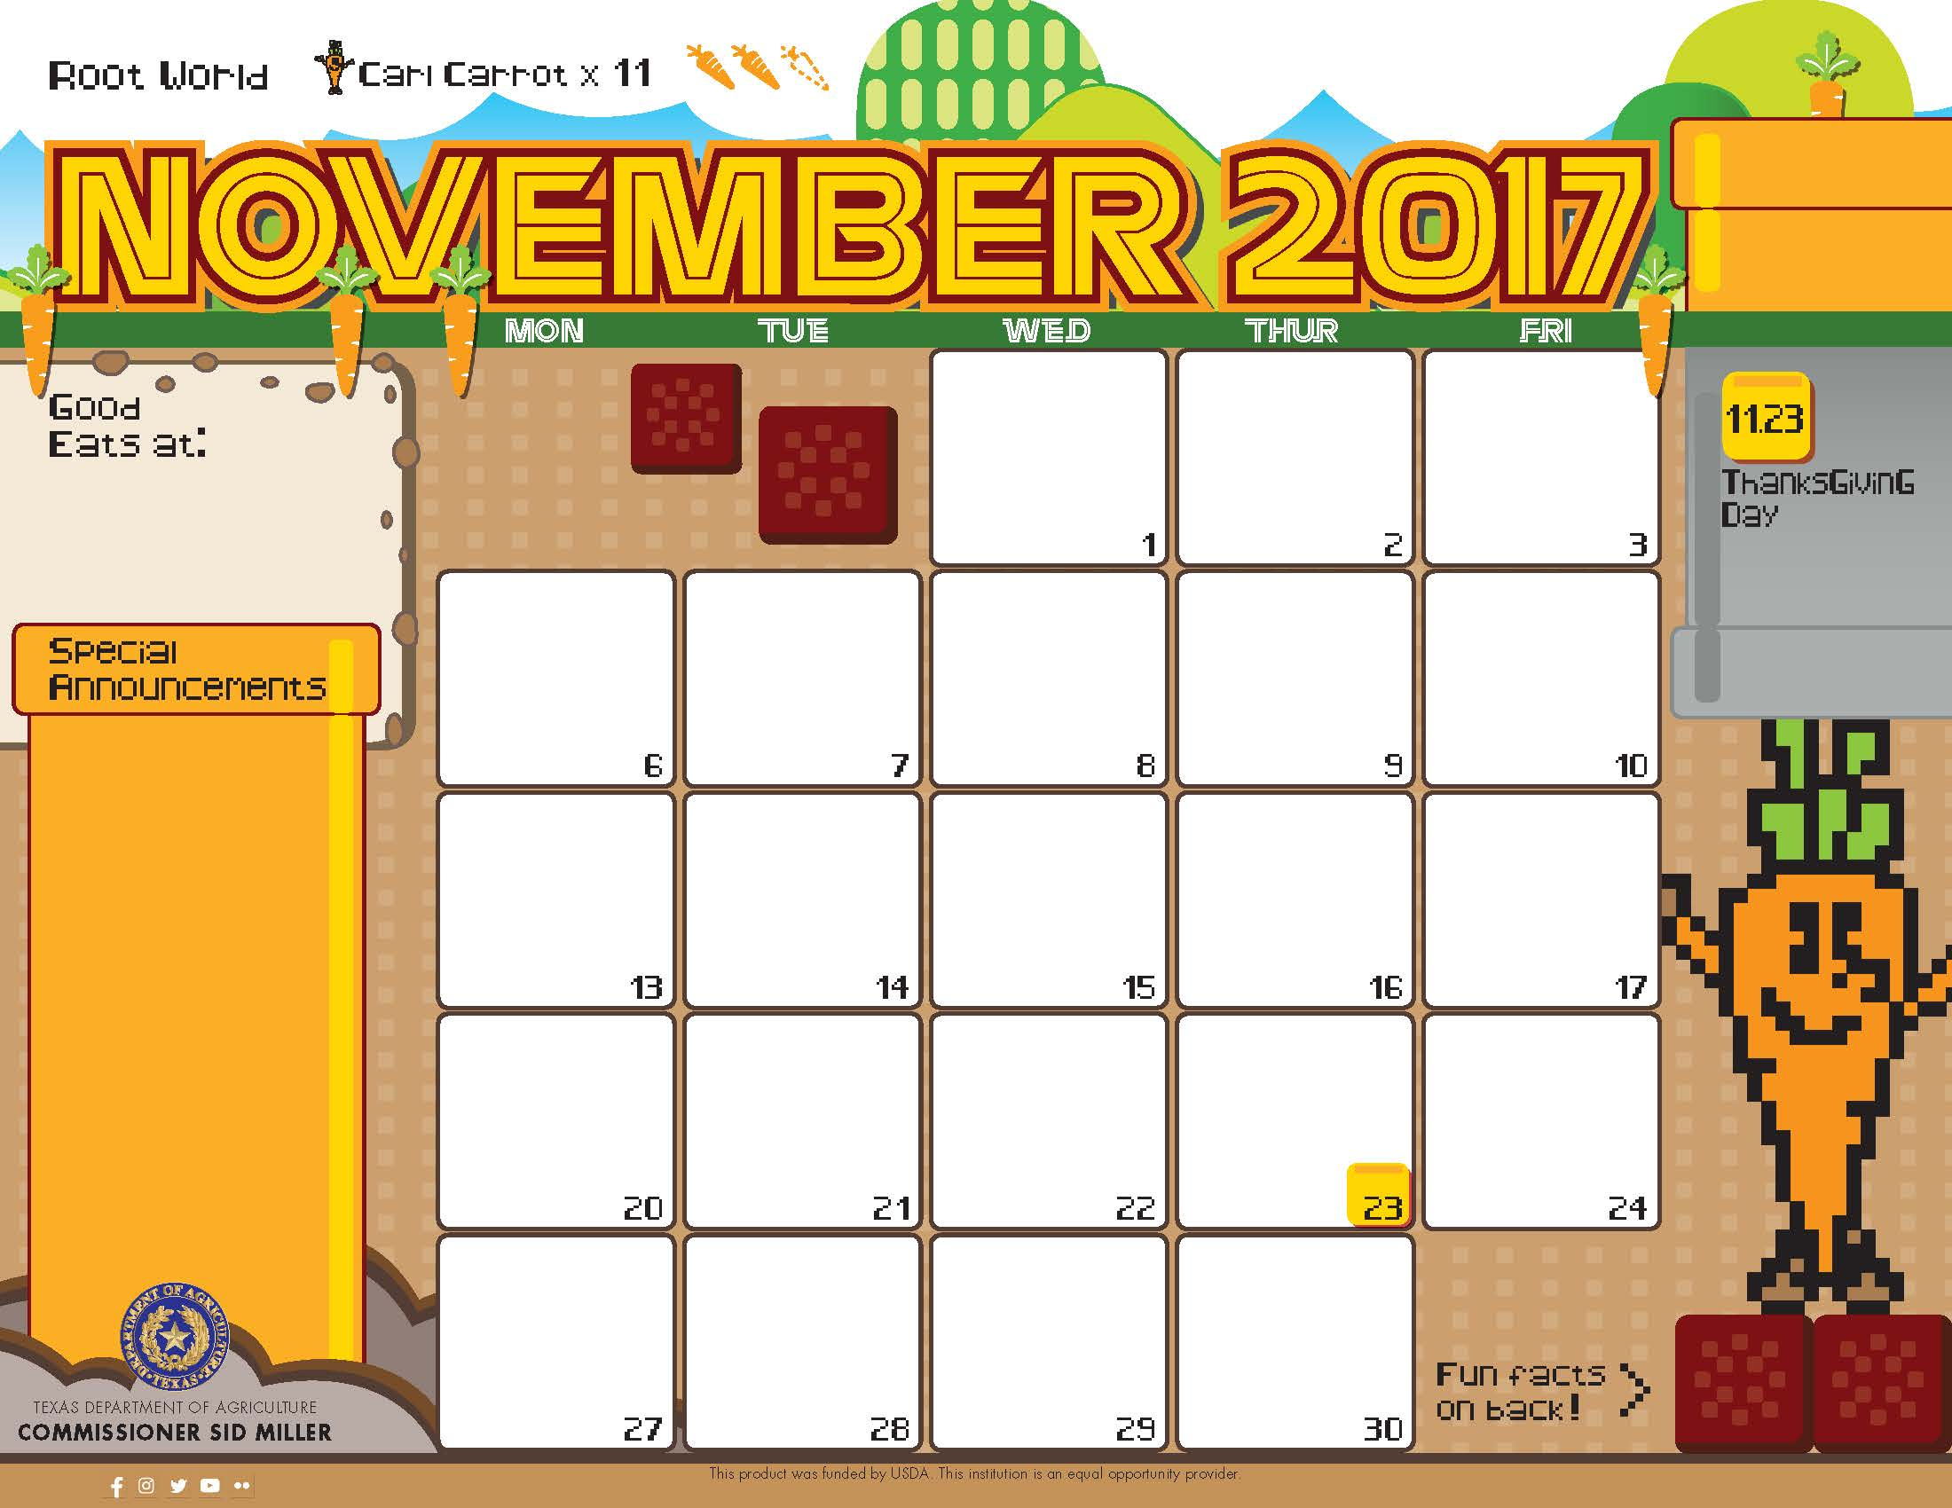

Egg> and Sausage

Pita Pocket

Assorted Fruits

Milk

Biscuits^

Sausage Patty

Banana

Dried Mixed Fruit”

Milk

Egg> and Potato

Pita Pocket

Assorted Fruits

Milk

Egg> and Bacon

Pita Pocket

Assorted Fruits

Milk

No School ☺

Pancake^>

Turkey Bacon

Orange

Agave

Milk

No School ☺

No School ☺

No School ☺

No School ☺

Pancake^>

Turkey Bacon

Orange

Agave

Milk

Breakfast

Baked Banana Crisp^>

Bunny Crunch Mix”

Milk

Breakfast Pizza^>

Applesauce”

Milk

Apple Cider Pancake^>

Turkey Bacon

Orange

Agave

Milk

Biscuits^

Scrambled Eggs>

Banana

Dried Mixed Fruit”

Milk

*Gluten Free

^Dairy

>Egg

`Fish

"Apple

Menu subject to change based on availability and costs

mario.alvarado@austin.utexas.edu kimberlywilson@austin.utexas.edu

**THANKSGIVING LUNCHEON**

**Fill out your form and return by November 3rd**

**$6 per adult meal**

Cinnamon Toast Bagel

Grapefruit

Milk

Breakfast Pizza^>

Applesauce”

Milk

Biscuits^

Chicken Patty

Banana

Dried Mixed Fruit”

Milk

Pumpkin Pie Oatmeal^

Bunny Crunch Mix”

Milk

Breakfast Pizza^>

Applesauce”

Milk

Orange Cranberry Pancake^>

Turkey Bacon

Orange

Agave

Milk

Biscuits^

Sausage Patty

Banana

Dried Mixed Fruit”

Milk



Hamburger

Lettuce and Tomato

Mashed Potatoes

Pear

Milk

Curry Chicken

Coconut Lime Rice

Peas

Apple”

Milk

Garlic Veggie^>

Caesar Salad’>

Applesauce”

Milk

Spaghetti with

Meaty Marinara

Carrot Raisin Salad^

Fruit Cup

Milk

No School ☺

Meatloaf*>

Steamed Carrots

Wheat Roll

Banana

Milk

Turkey w/Gravy

Cornbread stuffing

Wheat Roll

Green Beans

Cranberry Sauce

Milk

No School ☺

Orange Chicken

Rice

Asian Salad

Apple

Milk

Sweet and Sour Chicken

Rice

Broccoli Florets

Orange

Milk

No School ☺

Carne Guisada* Taco

Lettuce and Tomato

Cuban Beans

Apple

Milk

No School ☺

Red Beans and Cajun Rice

Longhorn Corn

Pear

Milk

No School ☺

Cheese Pizza^>

Greek Salad

Applesauce”

Milk

Hawaiian Fried Rice*

Aloha Beans

Apple

Milk

BBQ Chicken

Wheat Roll

Peas and Corn

Banana

Milk

Mac’n Cheese^

Broccoli Florets

Pears

Milk

Lunch

Chicken Enchilada Taco>

Pico De Gallo

Charro Beans

Pear

Milk

Veggie Fried Rice*>

Green Beans

Orange

Milk

*Gluten Free

^Dairy

>Egg

`Fish

"Apple

Menu subject to change based on availability and costs

mario.alvarado@austin.utexas.edu kimberlywilson@austin.utexas.edu

**THANKSGIVING LUNCHEON**

**Fill out your form and return by November 3rd**

**$6 per adult meal**

Chicken Fajita Taco

Peppers and Onions

Cauliflower

Orange

Milk

