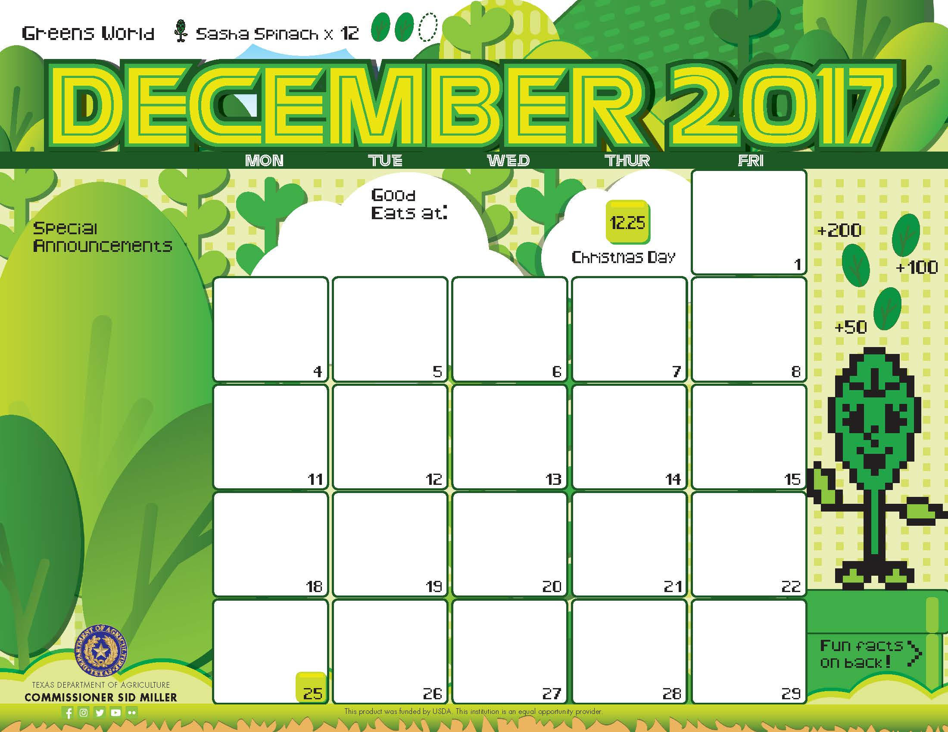

Egg> and Potato

Pita Pocket

Assorted Fruits

Milk

Breakfast

Biscuits^

Scrambled Eggs>

Banana

Dried Mixed Fruit”

Milk

Breakfast Pizza^>

Applesauce”

Milk

Baked Cherry Crisp^>

Bunny Crunch Mix

Milk

Pancake^>

Turkey Bacon

Orange

Agave

Milk

Egg> and Bacon

Pita Pocket

Assorted Fruits

Milk

\*Gluten Free

^Dairy

>Egg

`Fish

"Apple

Menu subject to change based on availability and costs

mario.alvarado@austin.utexas.edu kimberlywilson@austin.utexas.edu

Biscuits^

Chicken Patty

Banana

Dried Mixed Fruit”

Milk

Breakfast Pizza^>

Applesauce”

Milk

No School ☺

No School ☺

Cinnamon Toast Bagel

Grapefruit

Milk

Peppermint Pancake^>

Turkey Bacon

Orange

Agave

Milk

No School ☺

Egg> and Cheese^

Pita Pocket

Assorted Fruits

Milk

No School ☺

No School ☺

No School ☺

No School ☺

No School ☺

No School ☺

No School ☺



Cheese Pizza^

Caribbean Salad

Honey Lime Dressing

Applesauce”

Milk

Lunch

Cajun Chicken

Rice

Mexican Street Corn

Apple

Milk

Pulled Pork Taco

Pico De Gallo

Refried Beans

Chili Lime Mangoes

Milk

Powerhouse Chili

Wheat Roll

Carrot Coins

Pears

Milk

Spaghetti

Meaty Marinara

Green Beans

Banana

Milk

Mexican Pizza^

Caesar Salad’>

Applesauce”

Milk

\*Gluten Free

^Dairy

>Egg

`Fish

"Apple

Menu subject to change based on availability and costs

mario.alvarado@austin.utexas.edu kimberlywilson@austin.utexas.edu

Cheese Pizza^

Carrot Raisin Salad

Applesauce”

Milk

Asian Beef Taco

Stir Fry Slaw

Kung Poa Chickpeas

Pear

Milk

Fiesta Taco Bake^

Chili Cucumbers

Orange

Milk

Lemon Pepper Chicken

Wheat Roll

Broccoli Florets

Banana

Milk

No School ☺

No School ☺

Philly Cheese Mac^

Potato Wedges

Apple

Milk

No School ☺

No School ☺

No School ☺

No School ☺

No School ☺

No School ☺

No School ☺

No School ☺

