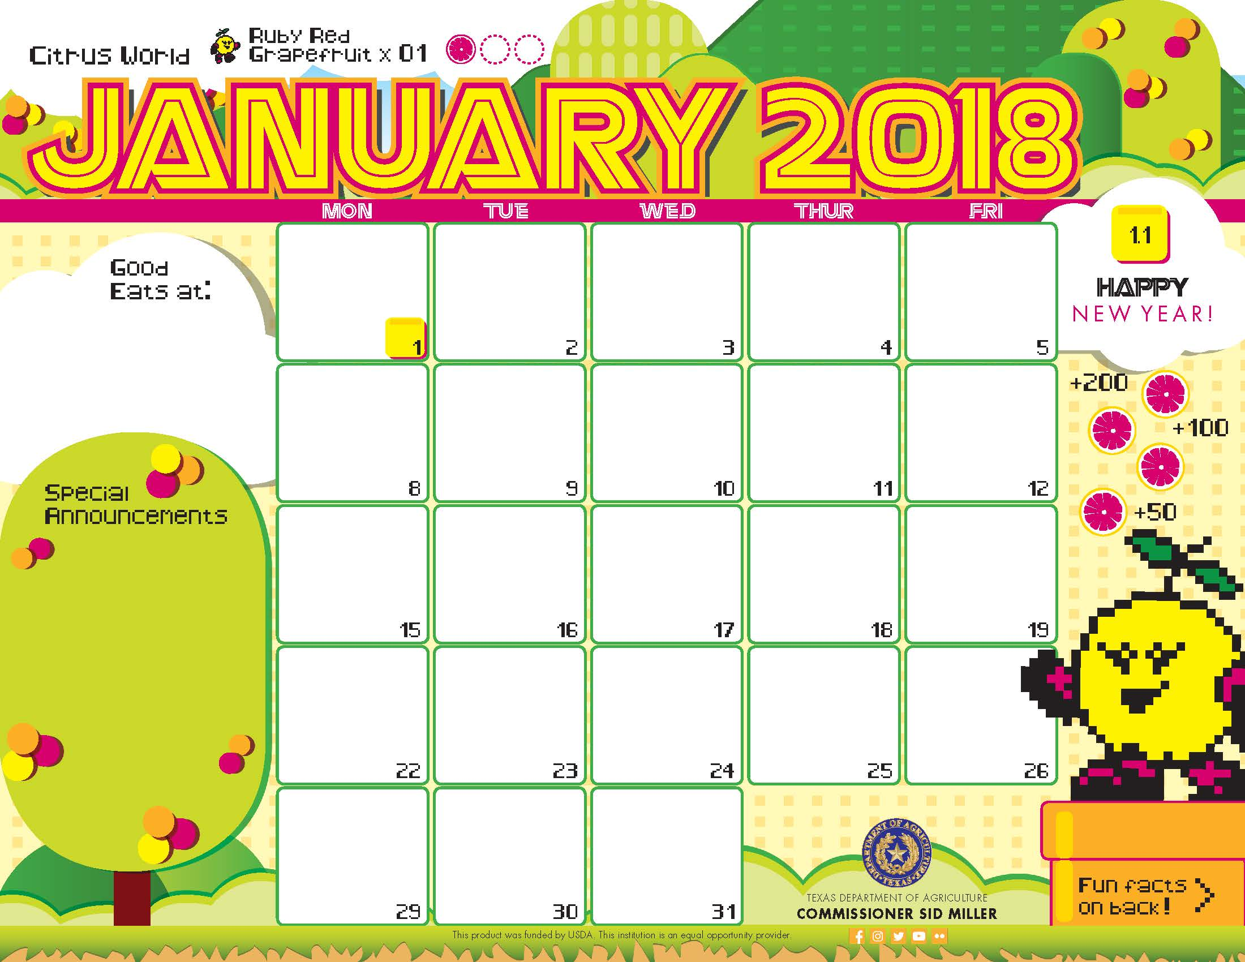

Biscuits^

Sausage Patty

Banana

Dried Mixed Fruit”

Milk

Egg> and sausage^

Pita Pocket

Assorted Fruits

Milk

Egg> and bacon^

Pita Pocket

Assorted Fruits

Milk

Egg> and potatoes^

Pita Pocket

Assorted Fruits

Milk

Egg> and Cheese^

Pita Pocket

Assorted Fruits

Milk

Pancake^>

Turkey Bacon

Orange

Agave

Milk

Pancake^>

Turkey Bacon

Orange

Agave

Milk

Lemon Poppy Pancake^>

Turkey Bacon

Orange

Agave

Milk

Cinnamon Toast Bagel

Grapefruit

Milk

Breakfast Pizza^>

Applesauce”

Milk

Baked Banana Crisp^>

Bunny Crunch Mix”

Milk

Breakfast Pizza^>

Applesauce”

Milk

Breakfast Pizza^>

Applesauce”

Milk

Breakfast

Strawberry Pancake^>

Turkey Bacon

Orange

Agave

Milk

Biscuits^

Scrambled Eggs>

Banana

Dried Mixed Fruit”

Milk

Biscuits^

Chicken Patty

Banana

Dried Mixed Fruit”

Milk

\*Gluten Free

^Dairy

>Egg

`Fish

"Apple

Menu subject to change based on availability and costs

mario.alvarado@austin.utexas.edu kimberlywilson@austin.utexas.edu

Biscuits^

Scrambled Eggs>

Banana

Dried Mixed Fruit”

Milk

Biscuits^

Sausage Patty

Banana

Dried Mixed Fruit”

Milk

Fruit and Yogurt Parfait

Grapefruit

Milk

Breakfast Pizza^>

Applesauce”

Milk



Mexican Meatloaf\*

Roasted Sweet Potatoes

Banana

Milk

BBQ Pizza^

Caesar Salad’>

Applesauce”

Milk

Cheese Pizza^>

Greek Salad

Applesauce”

Milk

Cheese Pizza^>

Caesar Salad`>

Applesauce”

Milk

Garlic Herb Pizza^>

Caesar Salad’

Applesauce”

Milk

Meatloaf\*

Coleslaw

Wheat Roll

Banana

Milk

Thai Baked Chicken

Thai Chopped Salad

Rice

Grapefruit

Milk

Orange Chicken

Rice

Asian Salad

Apple

Milk

Sweet and Sour Chicken

Rice

Broccoli Florets

Orange

Milk

Carne Guisada\* Taco

Lettuce and Tomato

Cuban Beans

Apple

Milk

Lasagna Bake^

Broccoli Florets

Orange

Milk

Red Beans and Rice

Longhorn Corn

Pear

Milk

Lunch

Beef Burger

Lettuce and Tomato

Mashed Potatoes

Pear

Milk

Catfish Taco

Cilantro Lime Slaw

Fiesta Beans

Pear

Milk

Curry Chicken

Coconut Lime Rice

Peas

Apple”

Milk

Chicken Enchilada Taco>

Pico De Gallo

Charro Beans

Pear

Milk

\*Gluten Free

^Dairy

>Egg

`Fish

"Apple

Menu subject to change based on availability and costs

mario.alvarado@austin.utexas.edu kimberlywilson@austin.utexas.edu

Beef and Broccoli

Lo Mein

Carrot Coins

Banana

Milk

Chicken Fajita Taco

Peppers and Onions

Cauliflower

Orange

Milk

BBQ Chicken

Wheat Roll

Hatch Chile Corn

Banana

Milk

Mac’n Cheese^

Broccoli Florets

Pears

Milk

