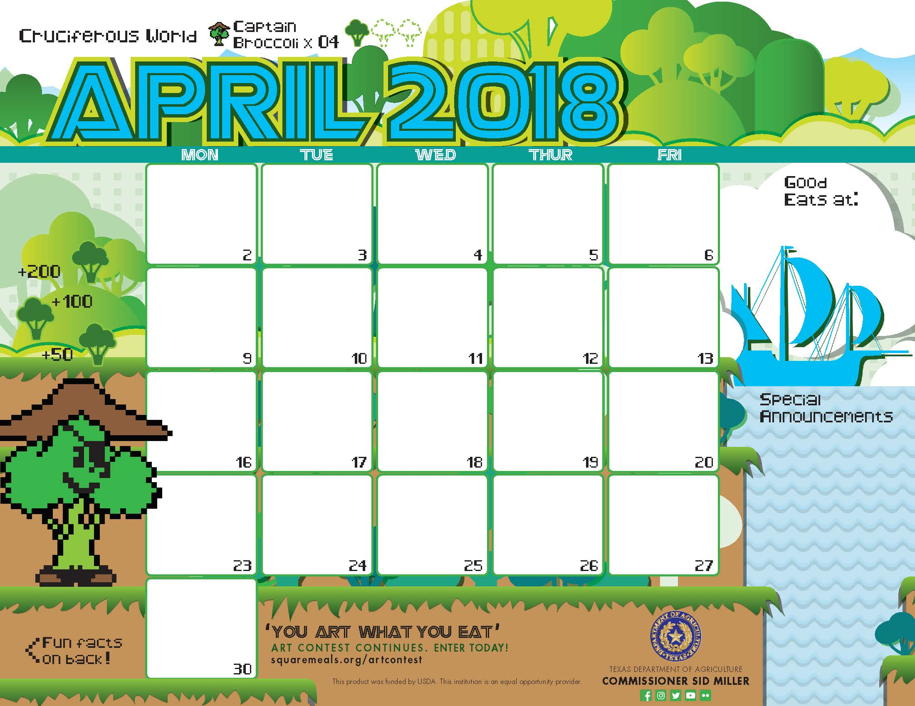

Breakfast Pizza^>

Applesauce”

Milk

Egg> scramble

Pita Pocket

Assorted Fruits

Milk

Egg> scramble

Pita Pocket

Assorted Fruits

Milk

Egg> scramble

Pita Pocket

Assorted Fruits

Milk

Pancake^>

Turkey Bacon

Orange

Agave

Milk

Pancake^>

Turkey Bacon

Orange

Agave

Milk

Biscuits^

Chicken Patty

Banana

Dried Fruit”

Milk

Biscuits^

Sausage Patty

Banana

Dried Fruit”

Milk

Biscuits^

Scrambled Eggs>

Banana

Dried Fruit”

Milk

Cinnamon Toast Bagel

Grapefruit

Milk

French Toast Bake^>

Grapefruit

Milk

Breakfast

Fruit and Yogurt Parfait^

UTES Granola Mix

Pear

Milk

Strawberry Pancake^>

Turkey Bacon

Orange

Agave

Milk

Breakfast Quesadilla ^>

Applesauce”

Milk

Breakfast Pizza^>

Applesauce”

Milk

\*Gluten Free

^Dairy

>Egg

`Fish

"Apple

Menu subject to change based on availability

and costs

[kimberlywilson@austin.utexas.edu](mailto:kimberlywilson@austin.utexas.edu)

[wayne.george@austin.utexas.edu](mailto:wayne.george@austin.utexas.edu)

Baked Peach Crisp^>

Mixed Fruit

Milk

Biscuits^

Chicken Patty

Banana

Dried Fruit”

Milk

Banana Pancake^>

Turkey Bacon

Orange

Agave

Milk

Egg> scramble

Pita Pocket

Assorted Fruits

Milk

Breakfast Quesadilla ^>

Applesauce”

Milk

Breakfast Pizza^>

Applesauce”

Milk



Hot Ham and Cheese Sandwiches

Classic Coleslaw

Baked BBQ Beans

Apple

Milk

Mexican Pizza^>

Caesar Salad`

Applesauce

Milk

BBQ Chicken Pizza^>

Caesar Salad`

Applesauce

Milk

Spaghetti with Meaty Marinara

Green Beans

Banana

Milk

Fish` Sticks

Broccoli Florets

Rotini Pasta

Banana

Milk

Cajun Meatloaf\*

Seasoned Rice

Longhorn Corn

Grapefruit

Milk

Beef Hamburger

Lettuce / Tomato

Wheat Bun

Pinto Beans

Apple

Milk

SW Turkey Taco

Pico De Gallo

Fiesta Beans

Pear

Milk

Chinese BBQ Pork Fried Rice

Sweet Potatoes

Grapefruit

Milk

Bevo’s Chili\*

Wheat Roll

Carrot Coins

Pear

Milk

Lunch

Cheese Pizza^>

Carrot Raisin Salad^

Sunshine Fruit Mix

Milk

Beef Hamburger

Lettuce / Tomato

Wheat Bun

Mashed Potatoes

Apple

Milk

Enchilada Chicken and Rice Bake\*

Chili Cucumbers

Orange

Milk

Chili Lime Catfish`

Green Beans

Wheat Roll

Grapes

Milk

Grilled Cheese

Tomato Basil Soup

Cauliflower

Pear

Milk

\*Gluten Free

^Dairy

>Egg

`Fish

"Apple

Menu subject to change based on availability

and costs

[kimberlywilson@austin.utexas.edu](mailto:kimberlywilson@austin.utexas.edu)

[wayne.george@austin.utexas.edu](mailto:wayne.george@austin.utexas.edu)

Cheese Pizza^>

Greek Salad

Sunshine Fruit Mix

Milk

Coconut Curry Pork

Coconut Lime Rice

Peas and Corn

Apple

Milk

Beef Hamburger

Lettuce / Tomato

Wheat Bun

Green Beans

Apple

Milk

Fish Taco`

Cilantro Lime Slaw^

Fiesta Beans

Chili Lime Mangoes

Milk

Beef Lasagna

Bake^

Broccoli Florets

Orange

Milk

Beef Fried Rice\*

Sesame Cucumbers

Pear

Milk

