The Social Emotional Learning Value for the month of March is:

ADAPTABILITY

Values in Action:
- Changing to new situations
- Thinking of solutions to problems
- Able to chance ideas or behaviors to be successful in a new environment or task

SEL Activity Ideas for Fostering Adaptability

Kinder-5th
Second Step: Creating a Support Tree second-step-student-resilience-activities.pdf (windows.net) (pg.4-6)

Middle School and High School

School-Connect Module 3.3. Bouncing Back from Setbacks

Resiliency in Nature: Read the poem, “The Rose that grew from concrete and have students think about what represents the concrete in their lives. What are their obstacles? Students can discuss as a group if they feel comfortable doing so. Next, discuss how they can “breakthrough concrete” like the rose What can they do or have they done to overcome their obstacles?

Turn this activity into an ELA assignment and have them write about their personal “concrete” and the things they can or have done to “breakthrough that concrete”.

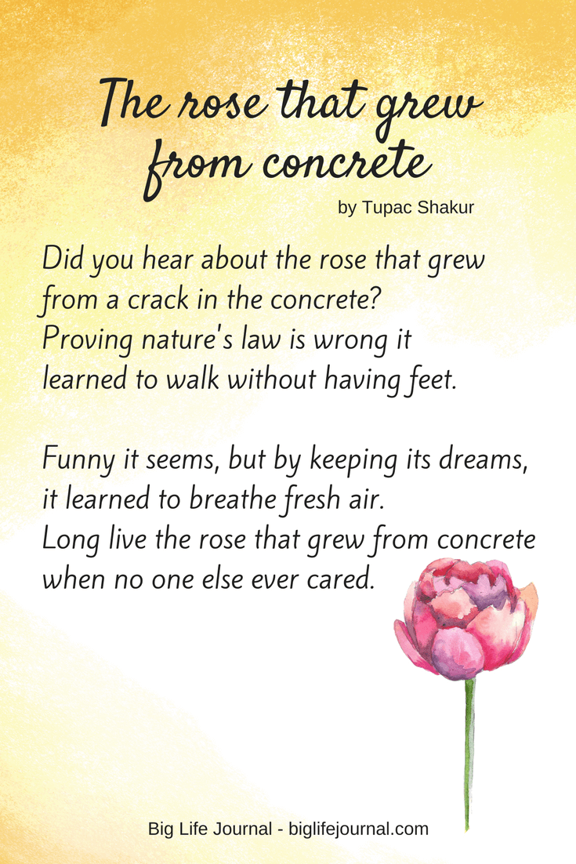

Grit Interviews: Have students conduct interviews or research individuals who have worked hard toward long term goals. Students should identify the obstacles the individual had to overcome and the characteristics and skills needed to overcome those obstacles.
Turn this into an ELA or History assignment!

